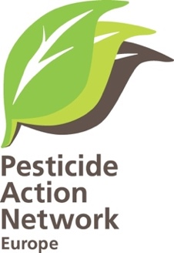

Programme for lunch time debate on
Making biodiversity work for farmers
Bringing ecology back into Ecological Focus Areas

When 13.30-15.00, Thursday 1 December 2016
Where: European Parliament room ASP 5 E 1

Background: Since 2015, the EU's Common Agricultural Policy (CAP) has a 'green component' meaning that bigger farmers are obliged to diversify the crops they grow and to dedicate 5% of their arable land for biodiversity. However, if these so-called ecological focus areas are used for crop production, particularly leguminous or nitrogen fixing crops, farmers can use pesticides. As part of the exercise to assess 'greening after one year' and see rules are fit for purpose, the European Commission is proposing to prohibit the use of pesticides on these areas.

The purpose of this workshop is to exchange on why this is such a good idea.

The workshop will be chaired by Michael Hamell, Professor of Agriculture, University College Dublin
- What is the European Commission actually proposing regarding ‘Greening after one year’ especially on pesticide use in Ecological Focus Areas? by Pierre Bascou Director in European Commission, DG AGRI
- Making EFAs work best for farmers and biodiversity by Prof. Felix Wäckers, pests in agricultural systems, University of Lancaster
- Sharing best practice on how to control pesticide use in EFAs by Jean-Pierre GODFRIN, Wallon department of control of agricultural expenses (invited)
Debate with Nicola Caputo, Maria Noichl,
Also invited for the debate: Paul Brannen, Christel Schaldemose, Eric Andrieu, Mairead McGUINNESS, Jan Huitema, Jasenko Selimovic, Marijana Petir, Bart Staes, Martin Häusling

